 | Application for FACES 10  Deadline is Friday Jan.20th 2023  You must provide  - Letter in French including information about  - your interests and activities  - your strengths, your areas of improvement  - why you would like to be in FACES  - why you think you would be a good choice for the program  along with information page, send letter to  applications-WSC@yukon.ca  - 2 ½ minutes Video in French – expectations are  posted on FACES webpage with instructions on how  to send it directly to Karine Bélanger  Be aware that we will also be contacting teachers at your home school for their recommendations – don’t ask them.  Information session available on Zoom on  - Monday Jan.9 between 7:30 and 8:00 pm  Zoom link will be available on FACES webpage  Contact Karine Bélanger at karine.belanger@yesnet.yk.ca if you have any specific questions  For more information, visit our website at  http://10faces.weebly.com/ | Student Information
 |  | This co-educational program is open to all Yukon
 |  | Grade 10 students. Rural students are able to gain
 |  | access to the program by arranging either one or
 |  | both semesters in Whitehorse by boarding at
 |  | Gadzoosdaa to attend Wood Street Centre and a
 |  | parent secondary school. Students must be able to
 |  | meet the physical demands of the program and the
 |  | academic portion at the Grade 10 level. Class size is 16.
 |  | Student Expectations
 |  | Students will be expected to take part in all program
 |  | activities in French. They will participate in self-
 |  | evaluation and group analysis. They will be asked to
 |  | keep a journal, both written and pictorial, prepare
 |  | presentations during the term, regularly write
 |  | tests and take final exams.
 |  | Inappropriate or unacceptable behaviour that puts
 |  | others at risk, whether in the classroom or outdoors,
 |  | will result in not being invited on a specific expedition
 |  | or dismissal from the program.
 |  | No outdoor experience is necessary, but the
willingness to work hard is essential.

Class size is limited to 16 students
French Achievement  Challenge  Environment  Stewardship  Put yourself in the picture …  Take part in FACES  and rise to the challenge! |  | 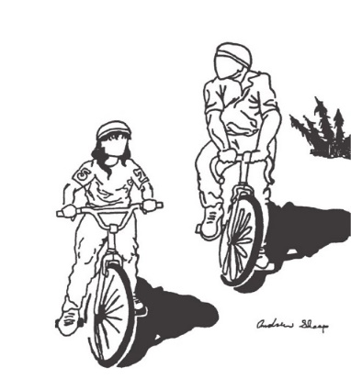

FACES 10 – A Journey for Body and Mind  General Program Description  FACES is about personal growth through personal challenge. Whether in the classroom or outdoors, learning experientially is about personalized education. FACES requires students to make a significant personal commitment, since many of the program experiences take place in remote settings. Expect to be actively involved in outdoor expedition settings. During these outings, you support and are supported by your fellow travelers in learning about yourself and about natural and cultural environments.  FACES selects outdoor activities and settings that are characterized as low impact and are relevant to current curriculum content. Trips provide significant opportunity for personal growth and development and personal connections to geography and history. FACES encourages each student to become a responsible citizen with the self-confidence and skills needed to meet the many challenges with the self- confidence and skills needed to meet the many challenges of a rapidly changing society.  Goals and Objectives  To encourage students to develop:  - a responsible attitude about learning, about themselves, about their role in society  - thinking and problem-solving skills through an integrated approach to academic subjects and outdoor activities  - knowledge and appreciation of the Yukon’s natural environment and cultural history  - a sense of stewardship for our natural and cultural environments  - a better understanding of history in Canada through study and firsthand experiences  - Self-confidence and self-discipline  - A heightened awareness and dedication to health and fitness  - Communication, teaching and observation skills  - Friendships and positive peer relationships  - Skill and knowledge in a range of low impact outdoor pursuits  - Co-operative attitudes and habits through group interaction | Major Expeditions  There will be a number of major expeditions planned for the semester. These expeditions integrate the students’ academic studies with the other program objectives.  Program Costs  Students are to pay a program fee of $350 at the beginning of the semester.  Students are not expected to buy a lot of equipment. Those who already have suitable gear will be expected to use it. All students are expected to provide their own food (expect approximately the same cost as eating at home). All specialized equipment will be provided.  The FACES Year  Students take FACES in Fall semester and a conventional program of courses in Spring semester.  FACES Semester Alternate Semester  Socials Studies 10 English 10  Science 10 Math 10  Outdoor Education 11 Français langue 10  Physical Education 10 Elective 10  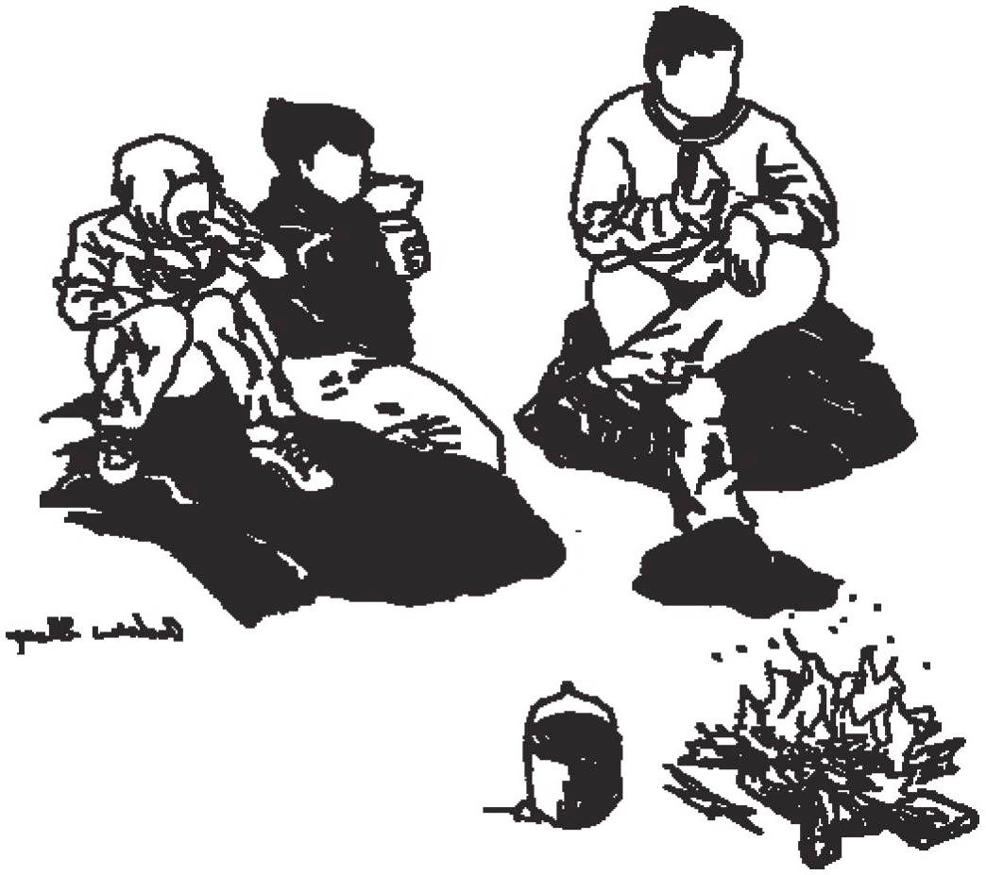 | Program Content  The four subjects offered with FACES develop the competencies and address the content of the standard Grade 10 BC curriculum. Course content is integrated extensively in the outdoor activities and expeditions.  Sciences Humaines 10 (4 credits)  The Grade 10 Social Studies Curriculum focuses on developing competency in inquiry skills, including: gathering, interpreting, and analyzing ideas, and communicating findings and decisions. The course content focuses on the study of Canada and the World from the early 1900’s to the present day.  In addition, students will develop an in-depth connection with local Yukon history, as they paddle rivers and bike along routes that were travelled for centuries by First Peoples, and in more recent times by the Gold Rush stampeders.  Sciences Naturelles 10 (4 credits)  Students will develop competencies in questioning and predicting; planning and conducting; and processing and analyzing information through the exploration of 3 Big Ideas:  - Genes are the foundation for the diversity of living things.  - Chemical processes require energy and its change as atoms are rearranged.  - Energy is conserved and its transformation can affect living things and the environment  Plein Air (4 credits)  Outdoor activities include training days and expedition settings in hiking/snowshoeing, cross-country skiing, biking and canoeing. Risk management, leadership skills and Leave-No-Trace camping skills are emphasized. As well, students will learn the skills necessary to become better leaders of outdoor pursuits.  Education physique 10 (4 credits)  Physical literacy and healthy and active living are integrated with outdoor pursuits. PE 10 will provide students with a wide range of exciting, challenging and rewarding daily physical activities, including: cycling, canoeing, cross- country skiing, snowshoeing, tobogganing, bouldering, broomball, etc.

