[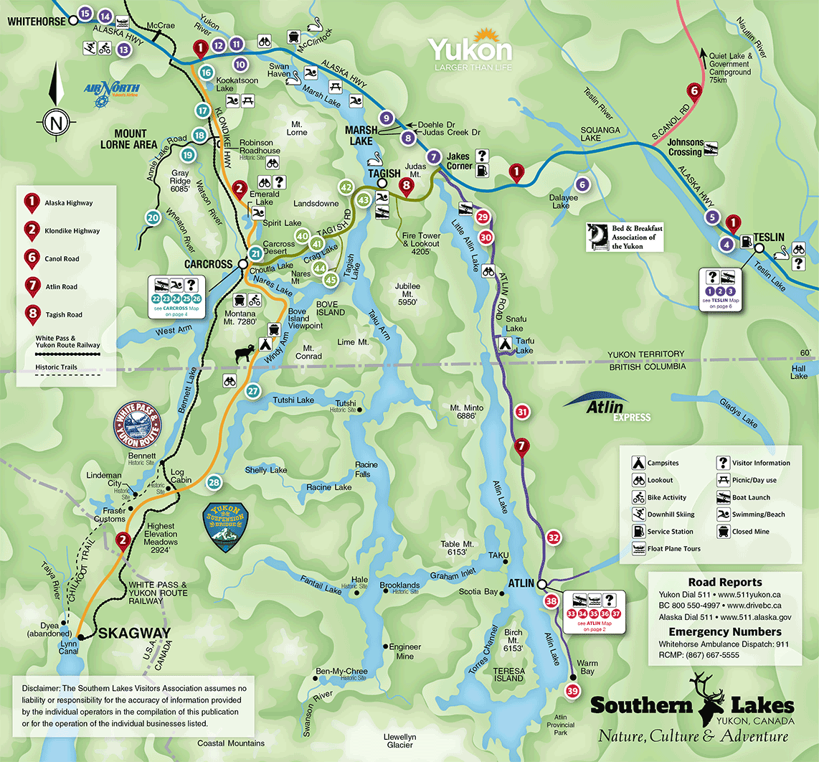](https://www.google.com/url?sa=i&rct=j&q=&esrc=s&source=images&cd=&ved=2ahUKEwiBv9aq95niAhVE7J4KHTjlDH8QjRx6BAgBEAU&url=https%3A%2F%2Fwww.southernlakesyukon.com%2Fmaps.html&psig=AOvVaw1-4SW5tDCueKHoJJLmown1&ust=1557885888111273)